|  |
| --- |
| April Word Images – Browse 30,664 Stock ... |
|  |
| **Special Notes for April 2025:**   * Your YASS Staff is Angela Francis and Lauren Voudrie * We will celebrate one birthday this month! YAY! * We will have a mini lesson by a member on “Fun Game Apps for Your Phone” and on “California” * We will make and bake mini personal pizzas. * Ms. Lauren will be teaching us all about Sourdough Bread Making. That will be fun! * We will have two m&m days (money matters). One session will have a mini lesson on budgeting and money handling. The second m&m class we will do our budget sheets for eating out. * We have two outings this month.  1. Wednesday, April 30 to Dairy Queen in Perryville, bring $10 to $15 depending on what you order. Remember to budget for a drink, appetizer/meal, and tax DROP OFF and PICK UP at t**he** restaurant. We will finish at 4:15 pm 2. Monday, April 14 to the Perry Park Cent for Gym time or Frisbee Golf DROP OFF and PICK UP at the Perry Park Center. We will finish at 4:30 PM |
| YASS APRIL 2025 |

|  |  |
| --- | --- |
| Monday | Wednesday |
|  | **2 YASS Canceled – Tornado Watch** |
| **7 Client Led Mini Lesson & Cooking Lesson**  Leadership Clip Art Vectors ... cooking-clipart-cooking-class-1 ... | **9 m&m class – lesson on Money Management**  M&M’s party decoration m and m characters prop for party decoration m and m  candy theme party m and m decorations for birthday m and m Calculator Money Clipart Images | Free ... |
| **14 Perry Park Center,Frisbee Golf, 4:30pm Pick Up**  Profile for Perry Park Center Disc Golf - New Orleans City Park | **16 Ms. Lauren & Sourdough Bread; Birthday**  Sourdough Vector Art, Icons, and ...Bread Baking Clip Art, Bread Clipart ...7,500+ Birthday Cake Clipart Stock ... |
| **21 Egg Hunt & Spring Celebration**  Easter Clipart Images – Browse 172,550 ... | **23 Movie Day at the office! Lilo & Stitch**  An Oral History of 'Lilo & Stitch,' A ...Movie Popcorn Soda Stock Illustrations ... |
| **28 m&m class & Client Lesson: California**  RED M&M DECAL / STICKER 13Budget Calculator Stock Illustrations ...Is California Considered A Sanctuary State For Immigrants - State Of California, HD Png Download, Transparent PNG | **30 Dairy Queen – Perryville, Pick up at 4:15pm**  Dairy Queen Grill Chill | Brands of the ... |

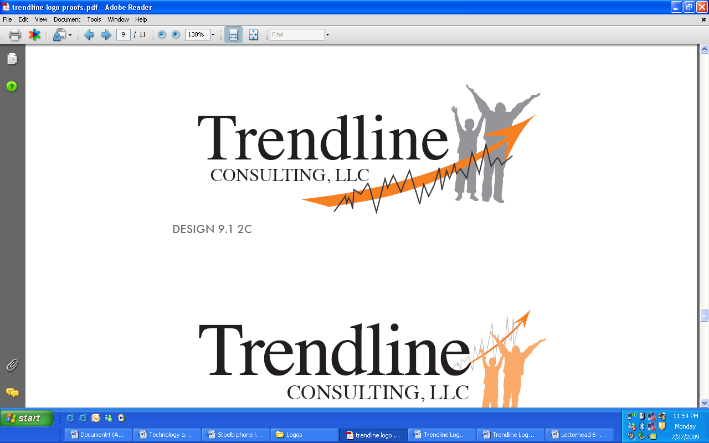

April 2025

(Parents send this back in)

**Young Adult Social Skills Group Outing Form & Permission**

**Please return it on or before: 04/09/2025**

I consent to _________________________________ attending as signed below. (Name of a group member)

I understand that Trendline Consulting staff will transport my child to and from the outings and will provide supervision during each event. I understand that outings will expose YASS members to new environments, experiences, and activities. While Trendline Consulting staff will supervise participants, it is each consumer’s responsibility to make his/her own choices. I will not hold Trendline Consulting or its employees liable for injury or loss that results from _______________________________’s actions or decisions except when they are caused by negligence on the part of staff. (Name of a group member)

|  |  |  |  |
| --- | --- | --- | --- |
| Guardian Signature | Outing Name | Date and Time | Locations and Details |
|  | **Perry Park Center**  **Perryville, MO** | Monday  04/14/2025  Perry Park Center  FREE!  Snacks: Your cost | * Consumers will meet at the PPC at 3pm Trendline will pay for their Frisbee Golf or gym use * If you want a snack or drink, you will need to bring your own money. * Parents pick up at the PPC at 4:30 pm |
|  | **Dairy Queen**  **Perryville, MO** | Wednesday  04/30/2025  Suggested amount: $10 to $15 | * Consumers will meet at Dairy Queen at 3pm * Consumers will need to bring money to purchase food & a drink. * Pick up at will be at Dairy Queen at 4:15 pm |

