

**General Session Information**

**SASS is currently led by Kim Sommers (979-480-5013), with help from Darian DeRousse (573-768-0920) and our newest member, Kaycee Walton (573-517-8483).**

* **We will continue to meet from 3-5pm on Tuesdays and Thursdays, except for our outing to Dairy Queen.**
* **. Each consumer will have their own envelope where they will keep track of and record their own SASS Cash.**
* **They can earn dollars for things like good behavior, listening, completing their jobs, and answering questions during lessons. They can also lose dollars for being rude to a peer or not listening or following directions. After each session, if they have earned $5, they can select a prize from my special prize drawer. At the end of the month, they must have $25 to be eligible to enter the SASS Store.**
* **I will let anyone know if your kiddo becomes ineligible to enter the SASS Store.**

**Outings & Other Fun Stuff**

**Thursday January 16: Dairy Queen Make-up Outing. We will go straight to Dairy Queen after school. Please provide money for Dairy Queen. Pick up at Dairy Queen at 4:30pm.**

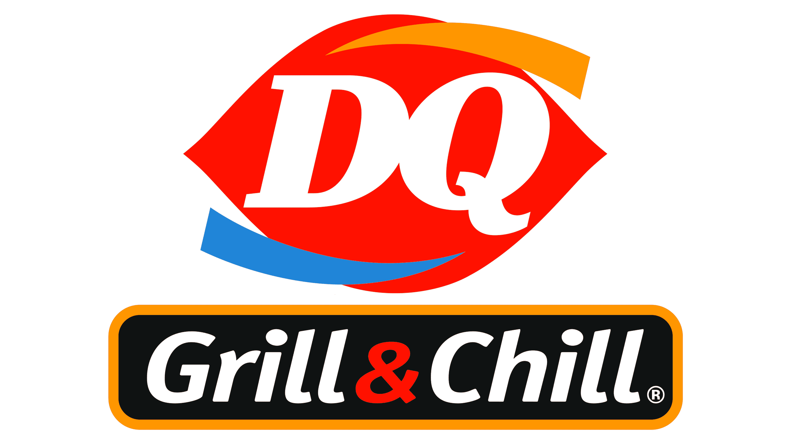

**Thursday January 23: Gaming Center Outing. We will begin at the office and go to the Gaming Center at 4pm. No cost. Pick up at the aming Center at 5pm.**

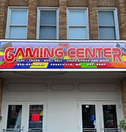

**Outings & Other Fun Stuff (Cont.)**

**Tuesday January 28: Movie/Pizza Day! We will eat pizza and watch the movie *Cars 3.* (Voted on by our kiddos.) Normal pick up at the office at 5. No cost.**



**Thursday January 30: CHINS Outing. We will head straight to CHINS after school. We will eat together and hang out as a group. Please provide money for CHINS. $15 will be plenty. Pick up at CHINS at 5pm.**

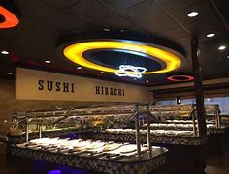

**SASS January Calendar**

**\*Parents – Keep this page\***

|  |  |
| --- | --- |
| **Tuesdays** | **Thursdays** |
| **Jan. 7- Canceled Weather Policy** | **Jan. 9- Canceled Weather Policy** |
| **Jan. 14- Regular Session 3-5pm** | **Jan. 16- Dairy Queen Outing** |
| **Jan. 21- Canceled Weather Policy** | **Jan. 23-Gaming Center Outing** |
| **Jan. 28- Movie & Pizza Party** | **Jan. 30- CHINS Outing** |

**SASS (Seriously Awesome Social Skills) January 2025 Permission Slip**

**Please sign and return it on Thursday 25. January outings were brainstormed and voted on solely by SASS members. This is a consent form that outlines the outings and activities planned for January.**

**I consent to (Please print Child’s Name) ________ attending these activities as signed below.**

**I understand that Trendline Consulting will provide transportation to and from the outings and will provide supervision at each event. I understand that outings will expose SASS members to new environments, people, experiences, and activities. While Trendline staff will supervise participants, it is ultimately each consumer’s responsibility to make his/her own choices. I will not hold Trendline Consulting or its employees liable for injury or loss caused by ____________’s actions or decisions, except for when they are caused by gross negligence on the part of staff.**

**Outing Details**

|  |  |  |  |
| --- | --- | --- | --- |
| **Guardian Signature** | **Outing Name** | **Date & Time** | **Outing Details** |
|  | **Dairy Queen** | **Jan. 16**  **3-4:30pm** | **We will go straight to Dairy Queen after school. Please provide money to eat. Pick up at DQ at 4:30pm.** |
|  | **Gaming Center** | **Jan. 23 3-5pm** | **We will begin at the office and have a snack. We will be at the Gaming Center at 4pm. No cost. Pick up at the Gaming Center at 5pm.** |
|  | **Movie & Pizza Party** | **Jan. 28 3-5pm** | **We will eat pizza and watch *Cars 3.* Pick up at the office at 5pm.** |
|  | **CHINS** | **Jan. 30 3-5pm** | **We will go straight to CHINS after school. Please provide money to eat. Pick up at CHINS at 5pm.** |

**\*\*Please sign next to each outing you are consenting to. Thx**